**Đáp án**

**Part I – 1**

1- D 2 – E 3 – G 4- B 5 – C

Part I – 2

1 – E 2- A 3 – H 4- C 5- G

Part I – 3

1- H 2- D 3- B 4- F 5- C

Part I – 4

1-A 2- C 3- D 4- G 5- F

Part I – 5

1-F 2- A 3- G 4- C 5- B

Part I – 6

1-D 2- B 3- A 4- H 5- F

Part I – 7

1-H 2- F 3- A 4- G 5- C

Part I – 8

1- D 2- C 3- G 4- A 5- F

Part I – 9

1- D 2- C 3- G 4- A 5- F

Part I – 10

1-F 2- H 3- E 4- D 5- B

Part I – 11

1-D 2- A 3- C 4- B 5- E

Part I – 12

1-H 2- F 3- E 4- A 5- G

Part I – 13

1-E 2- C 3- A 4- G 5- B

Part I – 14

1-G 2- B 3- D 4- H 5- A

Part I – 15

1-H 2- G 3- E 4- F 5- A

**ĐÁP ÁN - PART 2**

1C 2B 3C 4A 5A 6C 7B 8B 9C 10A

11A 12C 13A 14B 15C 16A 17C 18B 19A 20B

21A 22C 23A 24B 25C 26C 27A 28B 29B 30A

31C 32A 33B 34A 35C 36B 37B 38C 39A 40C

41B 42C 43A 44C 45B 46A 47A 48C 49B 50A

**Key Part 4.**

1.B 2.C 3.A 4.A 5.C 6.A 7.A

8.A 9.B 10.C 11.A 12.B 13.C 14.C

15.B 16.B 17.C 18.B 19.B 20.B 21.C

22.B 23.B 24.B 25.A 26.B 27.C 28.A

29.B 30.C 31.C 32.B 33.C 34.A 35.C

36.C 37.B 38.C 39.B 40.B 41.C 42.A

43.C 44.B 45.A 46.C 47.B 48.B 49.C

50.B 51.B 52.B 53.B 54.C 55.A 56.B

57.B 58.A 59.C 60.B 61.B 62.B 63.A

64.B 65.B 66.C 67.A 68.A 69.B 70.C

71.B 72.B 73.A 74.A 75.C 76.B 77.A

78.B 79.C 80.A 81.A 82.A 83.C 84.B

85.B 86.C 87.B 88.C 89.A 90.B 91.C

92.A 93.C 94.B 95.A 96.C 97.B 98.A

99.B 100.A 101.B 102.C 103.A 104.C 105.B

**KEYS FOR PART 5 ( EXTRA )**

TEST 11:

28.C 29.B 30. C 31.A 32. B 33. C 34. C 35. B

TEST 12:

28.C 29.B 30. A 31. B 32. C 33.B 34.A 35.B

TEST 13:

28. B 29. A 30. B 31. A 32. C 33. A 34. C 35. C

TEST 14:

28.A 29. B 30.A 31.C 32. A 33. B 34. B 35.B

TEST 15:

28.C 29.A 30.A 31.B 32. C 33.B 34. C 35. A

### Key part 6

**1. Places**

**36.** cinema **37.** library **38.** Hospital **39.** school **40.** stadium

**2. School subjects**

**36.** geography **37.** biology **38.** maths **39.** art **40.** history

**3. Rooms in a house**

**36.** bedroom **37.** kitchen **38.** bathroom **39.** garden **40.** living room

**4. Jobs**

**36.** nurse **37.** teacher **38.** waiter **39.** firefighter **40.** chef

**5. People in a family**

**36.** cousin **37.** uncle **38.** grandmother **39.** gunt **40.** niece

**6. Sports**

**36.** swimming **37. c**ycling **38.** football **39.** tennis **40.** jogging

**7. School things**

**36.** ruler **37.** Bag **38.** Pen **39.** Board **40.** notebook

**8. Travel words**

**36.** ticket **37.** map **38.** Sleeping bag **39.** Helmet **40.** plane

**9. Food and drink**

**36.** banana **37.** Orange **38.** Beef **39.** Milk **40.** beer

**10. Things to enjoy hobbies**

**36.** camera **37.** Tent **38.** Guitar **39.** Smartphone **40.** stamps

**11. Travel**

**36.** passport **37.** camera **38.** airport **39.** suitcase **40.** tourist

**12. Places**

**36.** garage **37.** station **38.** bridge **39.** stadium **40.** theatre

**13. Things at the beach**

**36.** boat **37.** fish **38.** sunglasses **39.** ball **40.** sandwich

**14. Parts of the body**

**36.** feet **37.** ears **38.** legs **39.** mouth **40.** teeth

**15. People in a family**

**36.** uncle **37.** son **38.** wife **39.** aunt **40.** daughter

**16. Holiday words**

**36.** book **37.** reception **38.** tent **39.** double **40.** beach

**17. Things in a house**

**36.** table **37.** cupboard **38.** shower **39.** window **40.** shelf

**18. Clothes**

**36.** shoes **37.** suit **38.** raincoat **39.** shorts **40.** sweater

**19. Things in your bag**

**36.** key **37.** glasses **38.** money **39.** comb **40.** diary

**20. Things at a party**

**36.** music **37.** present **38.** glass **39.** lemonade **40.** friends

**KIỂM TRA NĂNG LỰC NGOẠI NGỮ A2 – HỆ CAO ĐẲNG**

**ĐÁP ÁN - PART 7**

**1.**

1. in/near 2. from 3. have/’ve 4. are 5. my/the/one/our

6. his 7. if/when 8. to 9. am/’m 10. me

**2.**

1. on/next/this 2. With 3. me 4. can/could/should 5. for

6. like/love 7. The/my 8.a 9. Do 10. Be/come/arrive

**3.**

1. a 2. In/near 3. He 4. with 5. to

6. much 7. Went/travelled 8. was 9. Going/planning 10. of

**4.**

1.next 2. be 3. at 4. on 5. Must/have to

6. in 7. If 8. have 9. before/on 10. In

**5.**

1.to 2. for 3. but 4. Send/deliver 5. Will/is going to

6.on 7. but 8. were 9. Let 10. Hope

**6**.

1.since 2. more 3. than 4. Have 5.soon

6.letter 7. starts/begins 8. much 9. during/in 10.next

**7.**

1.at 2. having 3. ride 4. with 5.cooks

6.taught 7. would 8. for 9. but 10.tell

**8.**

1.hope 2. with 3. please 4. telephone 5.at

6.of 7. to 8.why 9. sorry 10.know

**9.**

1.from 2. Until/to 3. In 4. have 5.wash

6.send/mail 7.pay 8.clothes 9. watched 10.make

**10.**

1.starts/departs 2.bring/pack 3. on 4.go 5.be

6.light/warm 7.think 8.have 9. call 10.have

**11.**

1. application 2. in 3. As 4. Of 5. At

6. responsible 7. In 8. Realize/know 9.hope 10. How

**12.**

1. of 2. January 25 3. My/the 4. From 5. For

6. know 7. Just/recently 8. However 9. In 10. that

**13.**

1. in/near 2. from 3. have/’ve 4. are 5. my/the/one/our

6. his 7. if/when 8. to 9. am/’m 10. Me

**14.**

1. a 2. In/near 3. She 4. with 5. to

6. much 7. Went/travelled 8. was 9. Going/planning 10. of

**15.**

1.at 2. having 3. ride 4. with 5.cooks

6.taught 7. would 8. for 9. but 10.tell

**KEY PART 8:**

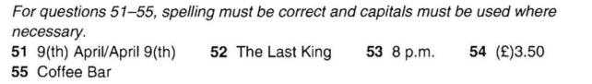1

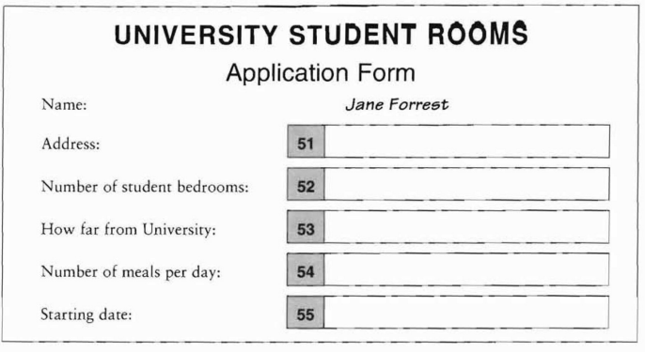5/ QUESTION 51-55

2

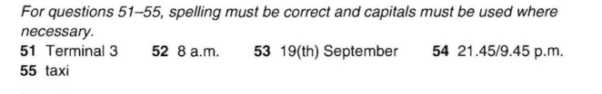

3



4



5/

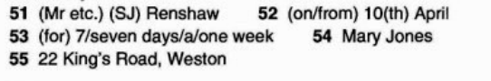

6/



7/



8/



9/



10/



11/

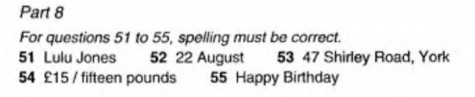

12/

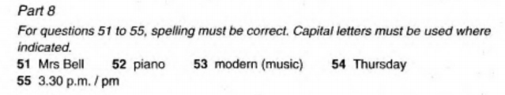

13/



14/

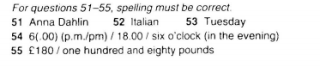

15/



**ANSWER KEYS - PART 9- WRITING**

**ĐỀ 1**

1. My hobbies are… (listening to music, travelling, cooking …)

2. I started my hobbies when I was…. (10 years old)

3. I often share my hobbies with…. (my friends)

4. I really feel… (relax)

5. I will …. (continue my hobbies in the future)

**ĐỀ 2**

1. My favourite city is …… (Danang)

2. It is located in… (the center of Vietnam)

3. It is about …. km from my home. (10km)

4. There are many … building in this place. (high and modern)

5. The good things here are ….. / The bad things are….

**ĐỀ 3**

1. (Vietnam) is in …
2. It got borders with…
3. The capital city is … / The currency is …
4. The official language is …/ People speak them in…
5. People study ….. at school.

**ĐỀ 4**

1. Classes always start at…
2. It takes …
3. We study…… at school?
4. My favourite subjects are and my favourite activities are….
5. There are also some extra activities after school such as: ….

**ĐỀ 5**

1. I am you going to go in …… at……
2. I am going to go with …
3. The weather is going ……..
4. I am going to take …………….on holiday?
5. I am going to …………….

**ĐỀ 6**

1. I usually get up at …
2. I usually ……….. in the morning?
3. I always go to school at ….
4. After school I often … (go out with my friends)
5. I usually ……… in the evening? (do my homework, watch TV)

**ĐỀ 7**

1 My friend’s name is ….

2 She has got …brothers and … sisters.

3 She likes….

4 There are some beautiful places in her town such as …

5 She speaks … and studies …..

**ĐỀ 8**

1. My full name is ………
2. I am … years old.
3. I live in … (Danang city)
4. There are … members in my family.
5. I am studying at … (Danang Vocational Training College)

**ĐỀ 9**

1. My favourite place is …. It is big with lots of …
2. It is located in ….
3. My interesting place in your area is ….
4. It was established in …
5. People in your area …..

**ĐỀ 10**

1. I went to ….(HCM city) last summer.
2. I got there by … (train) with …(my parents)
3. I stayed at … (a hotel)
4. I ….. there. (went to the museum, ate traditional food…)
5. The weather was …(nice) I really enjoyed it because …..

**ĐỀ 11**

**Write about your friend’s hobbies. Write 25-35 words.**

1. (Hung/Mai) is my best my friend. He/She likes …. (listening to music, travelling, cooking …)

2. He/She started his/her hobbies when he/she was…. (10 years old)

3. He/She often shares his/her hobbies with….

4. He/She really feels… (relax)

5. I think he/she will …. (continue his/her hobbies in the future)

**ĐỀ 12**

Write about a country you know. Write 25-35 words.

1. (Japan) is in …
2. It got borders with…
3. The capital city is … / The currency is …
4. The official language is …/ People speak them in…
5. People study ….. at school.

**ĐỀ 13**

**Write about Danang city.** **Write 25-35 words.**

1. My favourite city is …… (Danang)

2. It is located in… (the center of Vietnam)

3. It is about …. km from my home. (10km)

4. There are many interesting places in Danang such as ….

5. The best time to visit Da Nang is ….

**ĐỀ 14**

Write about your brother/sister’s school. Write 25-35 words.

1. Classes always start at…
2. It takes …
3. He/She studies…… at school.
4. His/Her favourite subjects are….. and his/her favourite activities are….
5. There are also some extra activities after school such as: ….

**ĐỀ 15**

1. My brother/sister’s full name is ………
2. He/She is … years old.
3. He/She lives in … (Danang city)
4. He/she likes …...
5. He/She is studying at … (Danang Vocational Training College)